PRODUCT SHEET: Luxembourg GM60

Version: ENGLISH

Date: July 2024

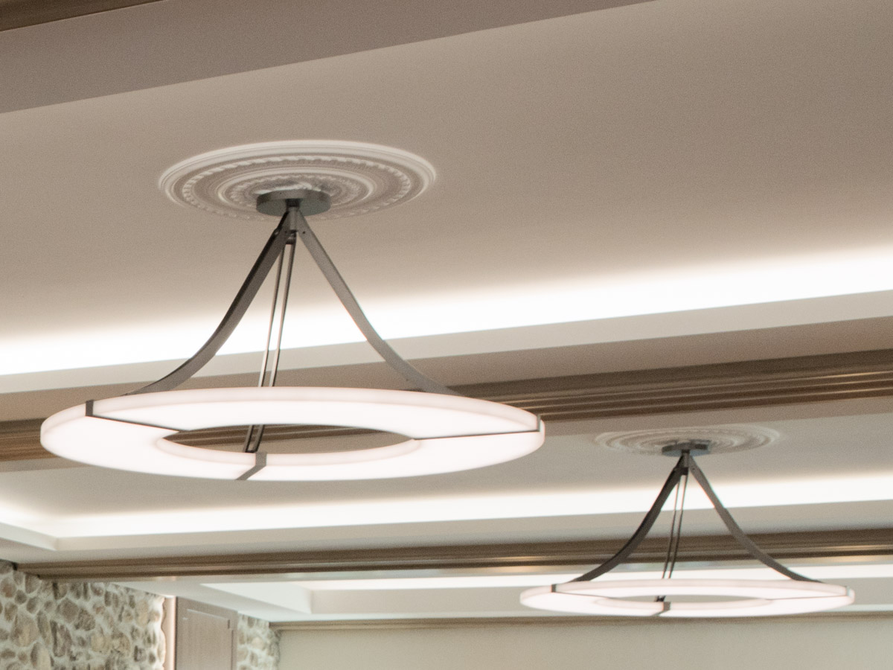

DESCRIPTION: Chandelier. Aluminium and brass structure.

Brushed bronze or gun metal finish. Frosted white acrylic shade.

Warm white 2200K LED down lighting, 210W, 6500Lumens.

Converter 24V non-integrated, to be placed in a distant box.

Weight: 24kg - 52lbs

Size: 120x120x60cm - 47.2x47.2x23.7in

Compliance: CE Class III

Origin: France

