PRODUCT SHEET: Luxembourg PM100

Version: ENGLISH

Date: July 2024

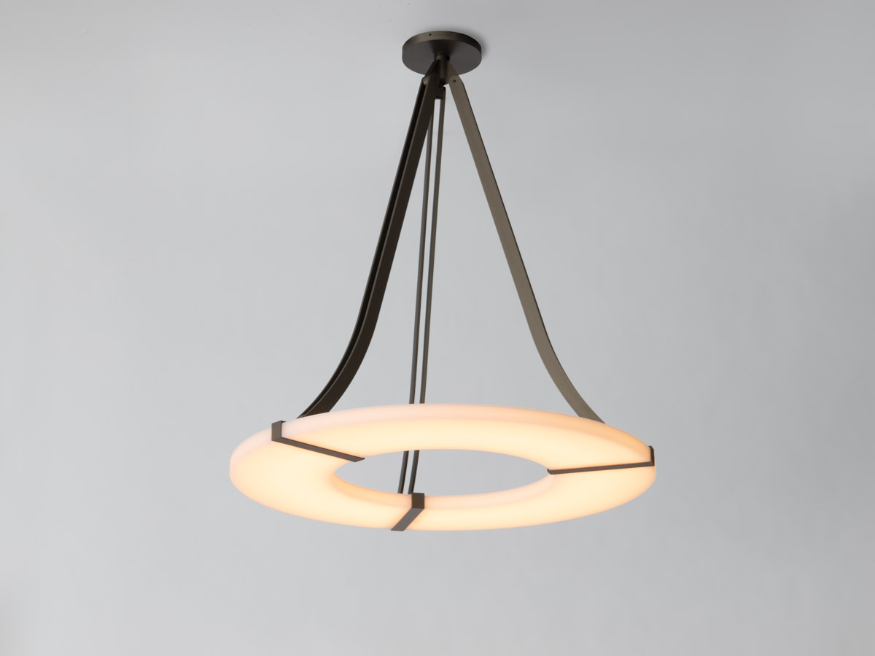

DESCRIPTION: Chandelier. Aluminium and brass structure.

Brushed bronze or gun metal finish. Frosted white acrylic shade.

Warm white 2200K LED down lighting, 120W, 3000Lumens.

Converter 24V non-integrated, to be placed in a distant box.

Weight: 16kg - 35lbs

Size: 90x90x100cm - 35.4x35.4x39.4in

Compliance: CE Class III

Origin: France

